Connor Paul

Database Example

**ER Diagram:**

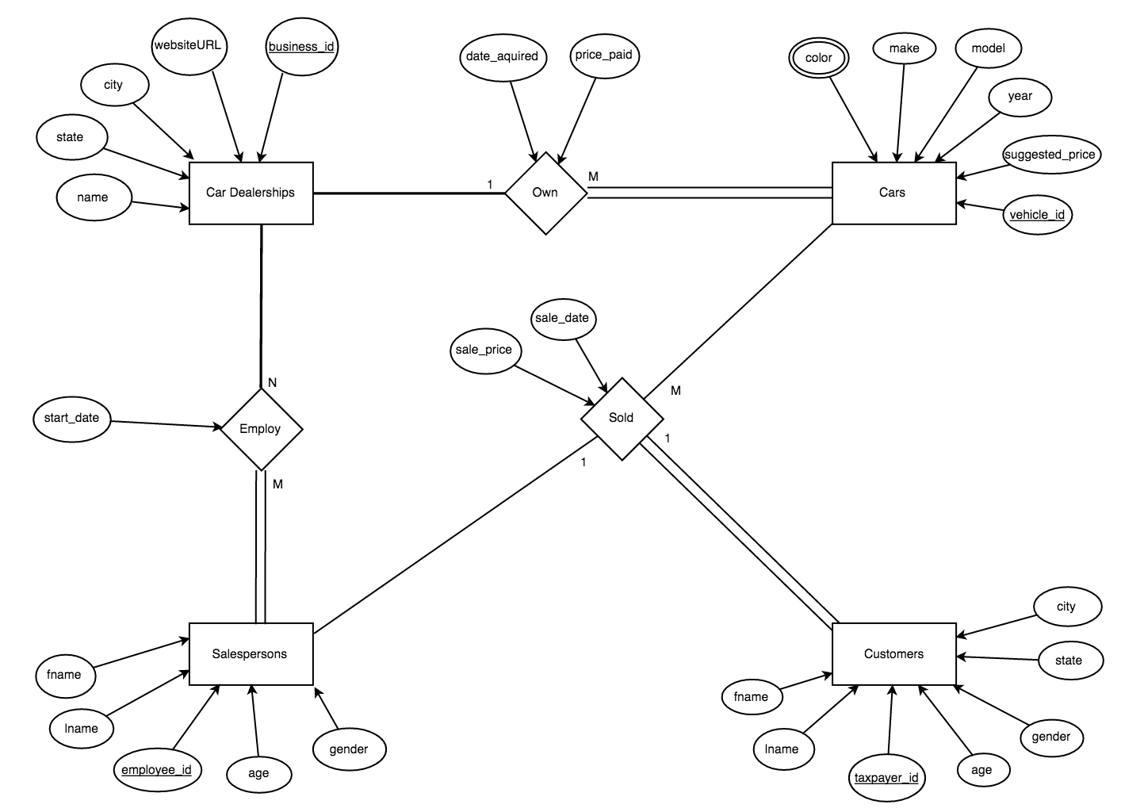

**Relation Diagram:**

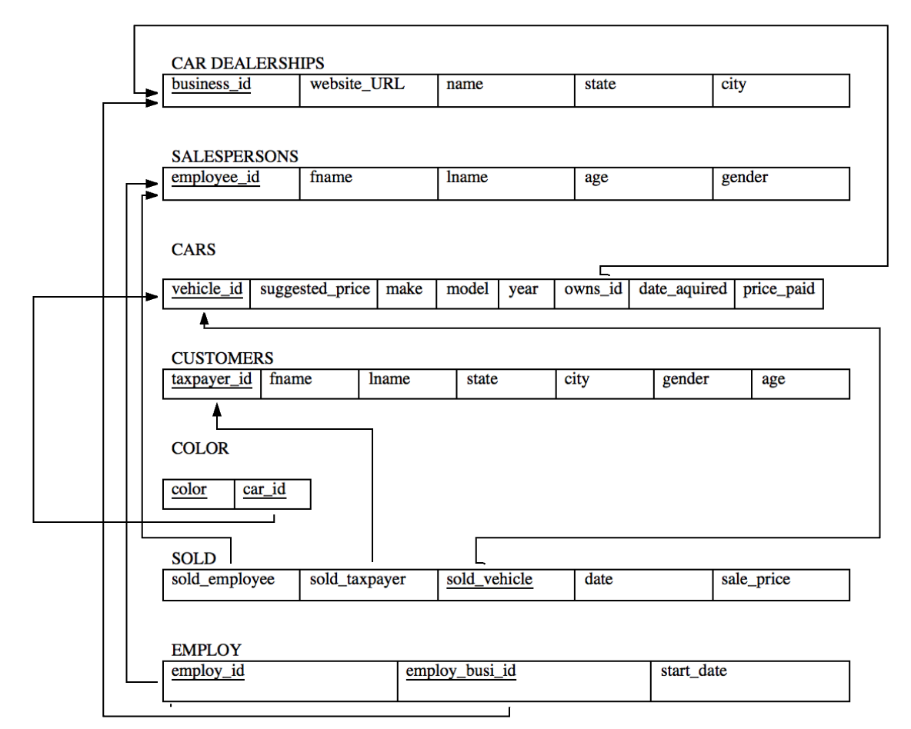

**Implementation (Create Table Statements):**

CREATE TABLE car_dealerships (

business_id int CHECK (business_id >= 1000 and business_id <= 9999), website_URL varchar(100) UNIQUE, name varchar(100), state char(2), city varchar(100),

primary key (business_id)

);

CREATE TABLE salespersons (

employee_id int CHECK (employee_id >= 100 and employee_id <= 999), fname varchar(50), lname varchar(50), age int CHECK (age>0 and age<130), gender char(1),

primary key (employee_id)

);

CREATE TABLE customers (

taxpayer_id int, fname varchar(50), lname varchar(50), state char(2), city varchar(100), gender char(1), age int CHECK (age > 0 and age < 130),

primary key (taxpayer_id)

);

CREATE TABLE cars (

vehicle_id int, suggested_price decimal(8,2), make varchar(15), model varchar(20), year year(4), owns_id int, date_aquired date, price_paid decimal(8,2),

primary key (vehicle_id),

foreign key (owns_id) references car_dealerships(business_id)

);

CREATE TABLE color (

color varchar(30), car_id int,

primary key (color, car_id),

foreign key (car_id) references cars(vehicle_id)

);

CREATE TABLE employ (

employ_id int, employ_busi_id int, start_date date,

primary key (employ_id, employ_busi_id),

foreign key (employ_id) references salespersons(employee_id),

foreign key (employ_busi_id) references car_dealerships(business_id)

);

CREATE TABLE sold (

sold_employee int, sold_taxpayer int, sold_vehicle int, date date, sale_price decimal(8,2),

primary key (sold_vehicle),

foreign key (sold_employee) references salespersons(employee_id),

foreign key (sold_taxpayer) references customers(taxpayer_id),

foreign key (sold_vehicle) references cars(vehicle_id)

);

**Queries and Output:**

1. List the first and last names of customers over 40 years old who purchased a Ford car.

select c.fname, c.lname

from customers c, sold so, cars ca

where c.taxpayer_id = so.sold_taxpayer

and ca.vehicle_id = so.sold_vehicle

and c.age>40

and ca.make = 'Ford';

|  |  |
| --- | --- |
| **fname** | **lname** |
| Chad | Paul |
| Tyler | Smith |

2. List the first and last names of salespersons who have NEVER sold a Ford car.

select DISTINCT s.fname, s.lname

from salespersons s

where s.employee_id NOT IN

(select DISTINCT so.sold_employee

from sold so, cars ca

where so.sold_vehicle = ca.vehicle_id

and ca.make = 'Ford');

|  |  |
| --- | --- |
| **fname** | **lname** |
| Connor | Paul |
| Brittney | Brinson |
| Christie | Brinson |
| Tiffany | Harris |
| Robert | Capra |
| Jenna | Hall |

3. List the total value (suggested price) of all cars owned by the dealership named ‘SILS Car Deals’.

select cd.name, sum(ca.suggested_price)

from cars ca, car_dealerships cd

where cd.business_id = ca.owns_id

and cd.name = 'SILS Car Deals';

|  |  |
| --- | --- |
| **name** | **sum(ca.suggested_price)** |
| SILS Car Deals | 132000.00 |

4. Find the average sales price (actual sales price, not suggested price) of a 2008 Honda Civic.

select ca.year, ca.make, ca.model, avg(so.sale_price)

from sold so, cars ca

where so.sold_vehicle = ca.vehicle_id

and ca.year = 2008

and ca.make = 'Honda'

and ca.model = 'Civic';

|  |  |  |  |
| --- | --- | --- | --- |
| **year** | **make** | **model** | **avg(so.sale_price)** |
| 2008 | Honda | Civic | 2333.333333 |

5. List the dealership name and the total number of cars that each dealership owns.

select cd.name, count(*)

from car_dealerships cd, cars ca

where cd.business_id = ca.owns_id

group by cd.name;

|  |  |
| --- | --- |
| **name** | **count(*)** |
| Audi of Winston Salem | 2 |
| Bob King Automall | 2 |
| Charlotte Ford | 1 |
| Pfafftown Chevy | 4 |
| SILS Car Deals | 2 |
| Volkswagen of Cary | 1 |

6. List the average age of customers who have purchased a car from salesperson ‘Homer Simpson’.

select avg(c.age)

from customers c, salespersons s, sold so

where c.taxpayer_id = so.sold_taxpayer

and  so.sold_employee = s.employee_id

and s.fname = 'Homer'

and s.lname = 'Simpson';

|  |
| --- |
| **avg(c.age)** |
| 38.3333 |

7. List the last name, employee id number, and the overall number of cars sold by each salesperson who has sold at least one Honda Civic.

select s.lname, s.employee_id, count(*)

from salespersons s, sold so

where s.employee_id = so.sold_employee

and s.employee_id IN

(select s.employee_id

from salespersons s, cars ca, sold so

where s.employee_id = so.sold_employee

and so.sold_vehicle = ca.vehicle_id

and ca.make = 'Honda'

and ca.model = 'Civic'

group by s.employee_id

having count(s.employee_id)>=1

)

group by s.lname;

|  |  |  |
| --- | --- | --- |
| **lname** | **employee_id** | **count(*)** |
| Capra | 543 | 2 |
| Hall | 666 | 2 |
| Simpson | 100 | 3 |

8. List the names of salespersons who have worked for all the car dealerships.

select s.fname, s.lname

from salespersons s

where NOT EXISTS (

select *

from employ e

where (

e.employ_busi_id in (

select cd.business_id

from car_dealerships cd)

and NOT EXISTS (

select *

from employ e1

where e1.employ_id = s.employee_id

and e.employ_busi_id = e1.employ_busi_id)));

|  |  |
| --- | --- |
| **fname** | **lname** |
| Homer | Simpson |
| Tiffany | Harris |